Supporting EF Guided Notes

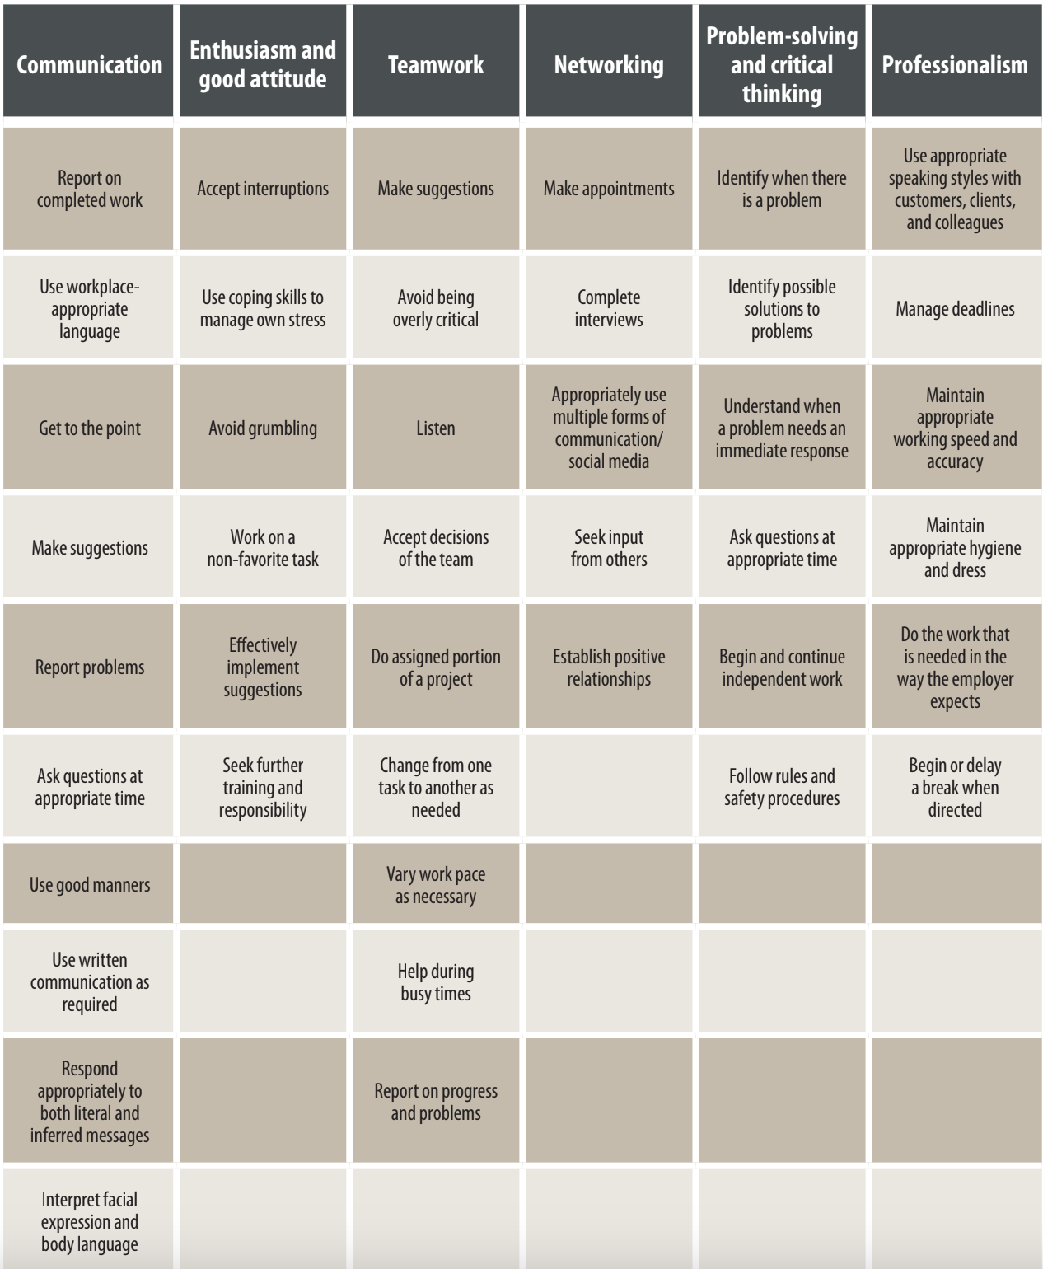

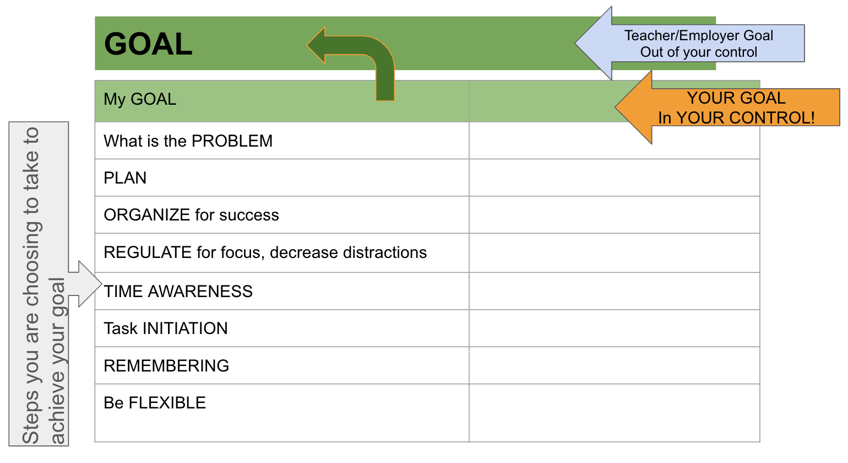
Executive Functioning tools I want to try:

Supporting EF Landing Page - Webinar Links, Resources discussed during presentation

