Helpful Webinars/ Videos  How Do You Support Executive Functioning During Online Learning?  Unstuck and On Target:  Part 1 Part 2 Part 3  Executive Functioning Skills: STOP Strategy  Executive Functioning: “Job Talk”- Developing Independent Executive Function Skills  YouTube Videos: What is EF?  How Children and Adults Can Build Core Capabilities for Life  Executive Function: Skills for Life and Learning  How to ADHD toolbox  How to ADHD - Wall of Awful | Informal Assessments  K-5th Checklist  Learning Style Inventory  Peg Dawson & Richard Guare Questionnaire  Questionnaire by Sarah Ward  LifeSkills Advocate Free EF AssessmentLifeSkills Advocate  K&M Center - online quiz | Documents/ Articles  Executive Functioning Developmental Chart  LD @ School - working memory  Harvard’s Enhancing and Practicing EF Skills Infancy-Adolescence  Games to Support Executive Functioning Skills  Working Memory Boosters  Executive Functioning Worksheet | Websites:  Brainline: School Based Assessment  K&M Center  A Day in Our Shoes: EF IEP Support  NE ATP- EF Supports that fit in your pocket  StudySkills.com (SOAR)  My ADHD Toolbox - EF tools  I'm Determined - goal forms & more  Diffit - get “just right” resources  Eisenhower Matrix  Especially Education - visual supports to support behavior
Books/Curriculum - Check with your regional coordinator for availability from the ASD library
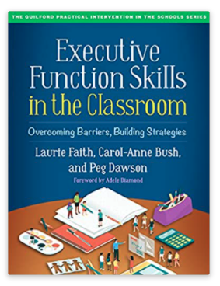
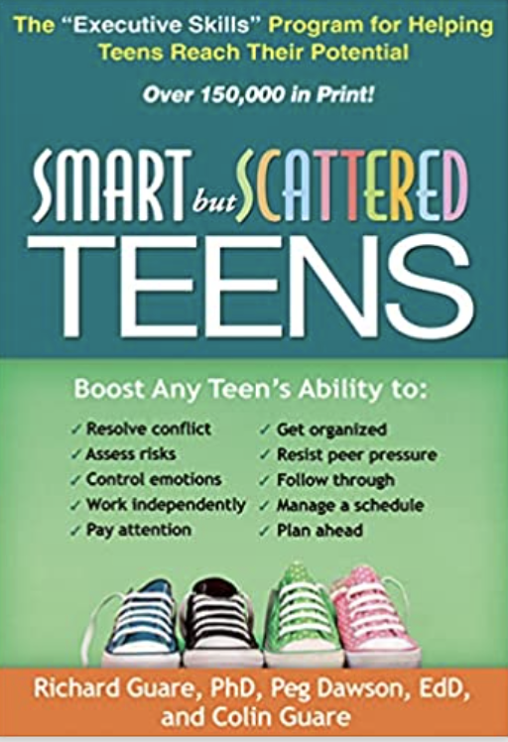

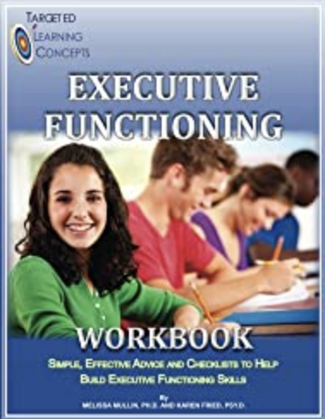
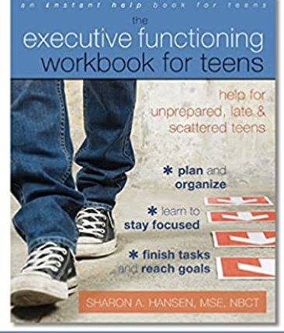
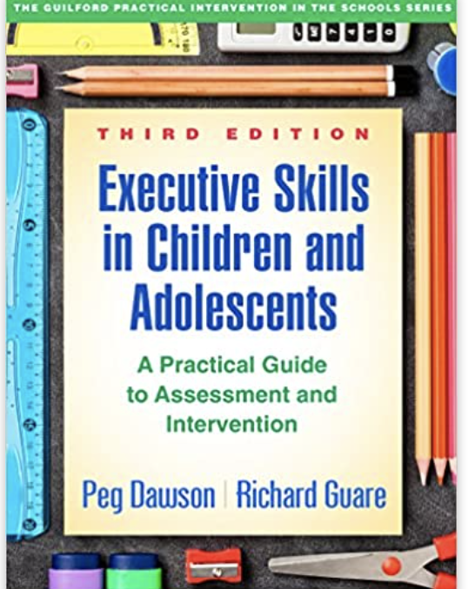
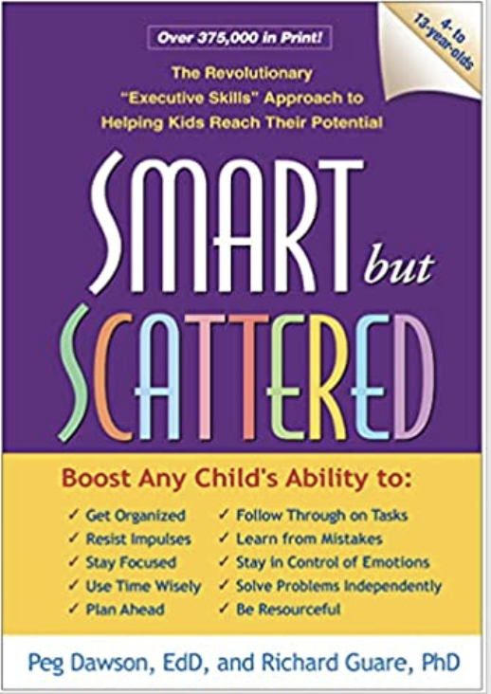
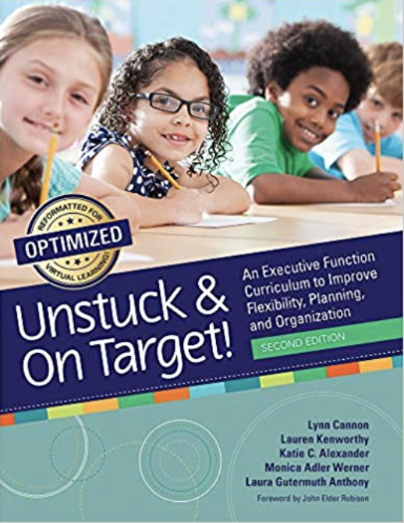
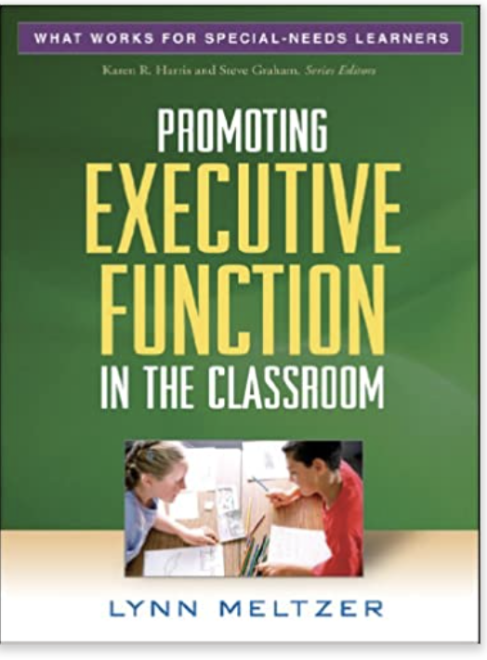

Age: 3-8 Age: 3-22 K-12 Age: 8-11 K-8 Teens Teens Age: 4-13 K-12 K-12

Presentation: Guided Notes

