Go to https://nedrivingconcern.org/ and click on the Traffic Safety Concerns heading (see image below). An expanded drop down menu of resources for specific driving safety topics will come up. Here you can further explore the concepts from the Chat ‘n Chow zoom!

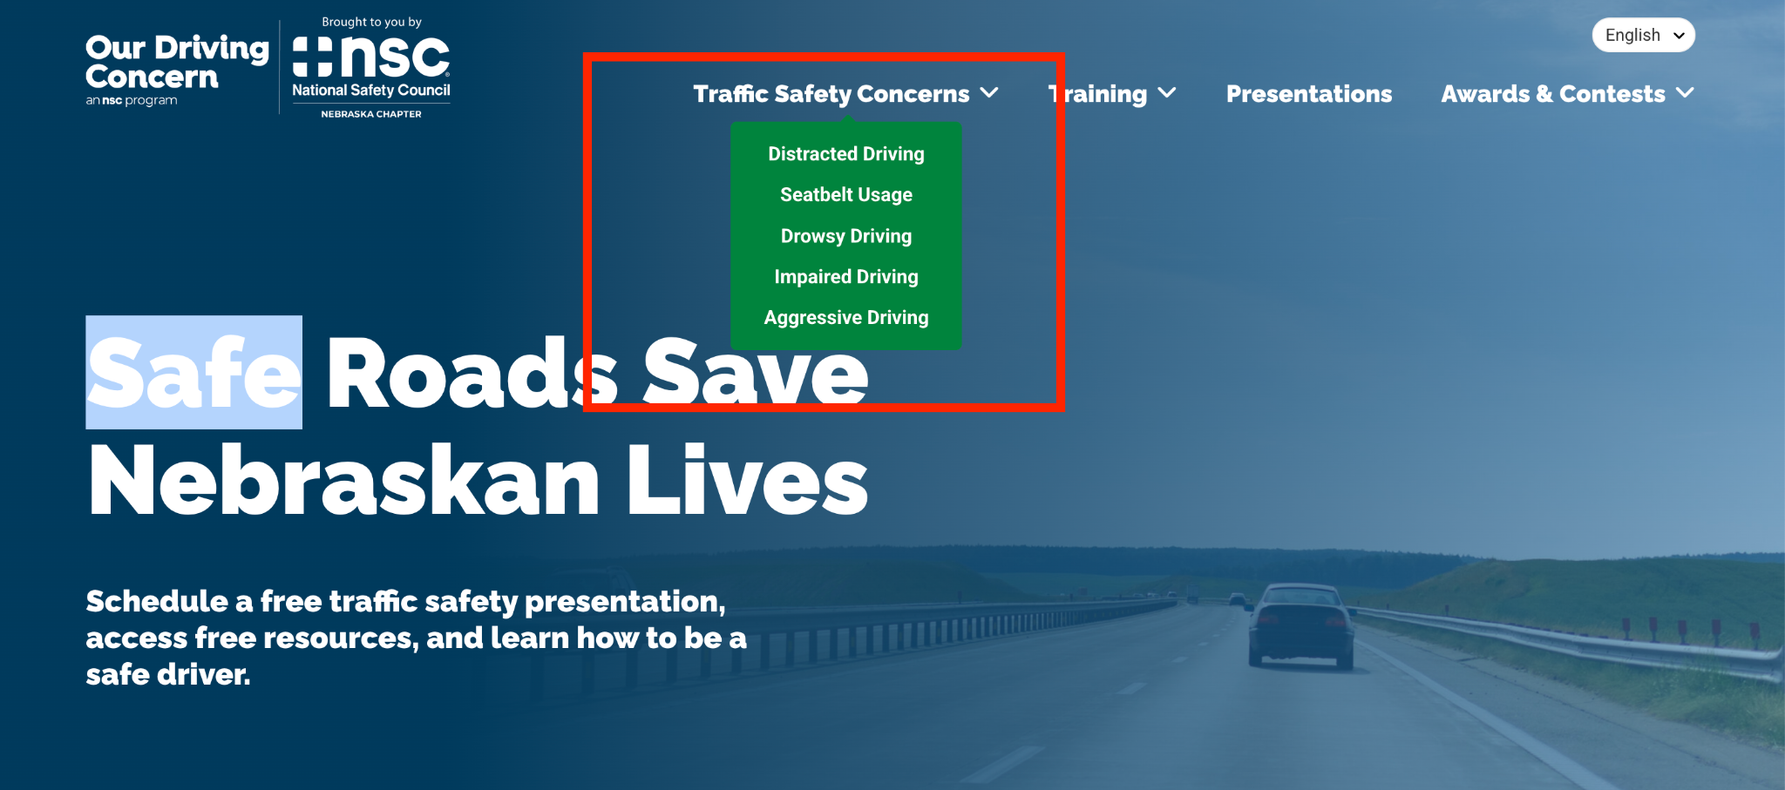

—-------------------------------------------------------------------------------------------------

Other useful links:
Nebraska DMV Overview of Graduated Driver's Licensing
National Highway Traffic Safety Administration Teen Driving
AAA Teen Safe Driving Resources

